*`*



**MEMORANDUM**

FOR : **PCOL ROY A MAGSALAY**

Provincial Director, Lanao del Norte PPO

Camp Gallego, Pigcarangan, Tubod, LDN

(ATTN: C, PIDMU)

FROM : Officer in-Charge, Maigo MPS

SUBJECT : **Intensification on Arrest of Wanted Person**

DATE : December 12, 2024

1. References:
2. VI from C, PIDMU dated December 12, 2024; and
3. Manhunt Charlie and Standard operating procedure.
4. Intensification of Wanted Person dated December 12, 2024. During Monthly UPER for the month of November 2024 conducted via blended conference dated November 29, 2024.

1. 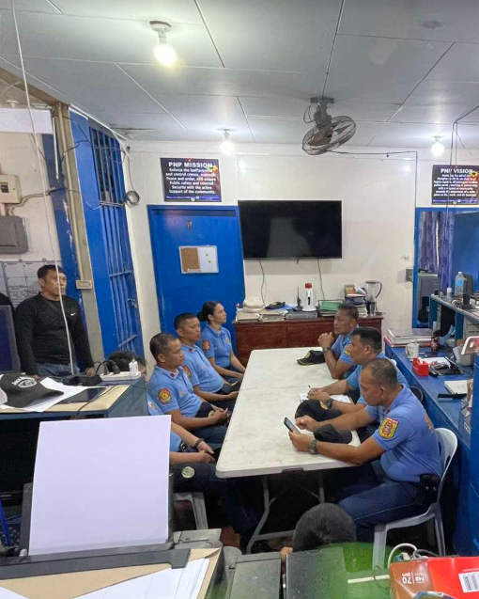 In this regard, At around 8:00 in the morning of December 12, 2024, PCPT RODELIO G DIEZ OIC, conducted PICE regarding the intensification on the arrest of Wanted person and instructed the personnel to monitor and extremely vigilant on their area of responsibility for possible arrest of your remaining wanted person.

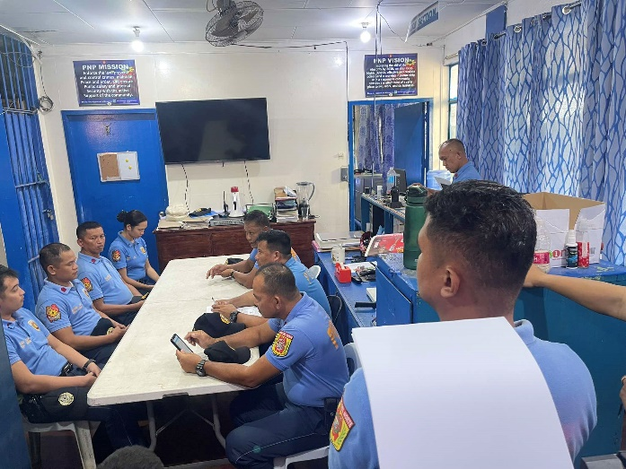

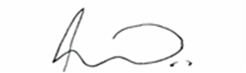

**PCPT RODELIO G DIEZ**

Officer In Charge